|  |  |
| --- | --- |
|  | **2019 연세-넥슨 √*i***  **RC 창의플랫폼 중간보고서** |

|  |  |
| --- | --- |
| **프로젝트명** | AutoTime |
| **모임 일시 및 장소** | 1. 7월 1일~8월30일 (방학)  - 참석자: 피주원, 최기주, 노재학, 문재웅  - 논의내용: Completion of software and finalization of microwave electronics design  2. 9.16(월) 19:00~20:00 (학생회관)  - 참석자: 피주원, 최기주  - 논의내용: Discussion on future plans of the project and promotion of microwave.  2. 9.19 (목) 20:00~22:00 (언더우드기념관 A311)  - 참석자: 피주원 노재학, 문재웅  - 논의내용: Testing software on microwave computer and start design on the server. Modifications on electronics design.  3. 9.24 (화) 20:00~22:00 (언더우드기념관 A308)  - 참석자: 피주원 노재학, 문재웅  - 논의내용: Further development on server software and  4. 9.25 (수) 17:00~18:00 (학생화관)  - 참석자: 피주원 최기주  - 논의내용: Discussion on the design of the User Interface of the microwave software  5. 9.26 (목) 20:00~22:00 (학생화관)  - 참석자: 피주원 노재학, 문재웅  - 논의내용: Implementation on the new User Interface design and further development on server software   * 총: 피주원(8시간), 문제웅(6시간), 최기주 (2시간), 노재학 (6시간) |
| **참여 인원** | 치원 하우스 피주원 (대표), 알렌 국제 하우스 문재웅, 운동주 하우스 최기주, 백양 하우스 노재학 |
| **프로젝트 목적** | To create a ‘smart microwave’ that automates processes such as power and time settings by using a barcode scanner to identify products and set time and other settings automatically. Through Wi-Fi and a custom server that keeps records on each product, new products that came later than the microwave can still be used. |
| **진행된 사항** | During the term break, the core functionality if the software which the microwave will run on are completed. Currently, it only needs slight modifications to the User Interface to make it more easily accessible to the user. Development of the server software is halfway done. The electronics part of the microwave is on the final stages of design and running tests. We are currently selecting and contacting suppliers that can make our designs. |
| **향후 계획** | We plan to complete the software part of the project (microwave and server) by the 2nd week of October. We aim to receive and assemble the electronics by the 3rd week of October and assemble the final product by October. If these objectives are achieved, the first week of November will be dedicated to promotion and surveying of the product to gather data of potential commercialization. |
| **예산집행**  **내역** | |  |  |  |  |  | | --- | --- | --- | --- | --- | | **내용** | **수량** | **내역** | **총금액** | **비고** | | None |  |  |  |  | |  |  |  |  |  | | 총 비용 |  |  |  |  | |
| **기타** | It was difficult to conduct offline meetings during the term break due to living in different regions and holiday. |

**기록/확인 피주원**

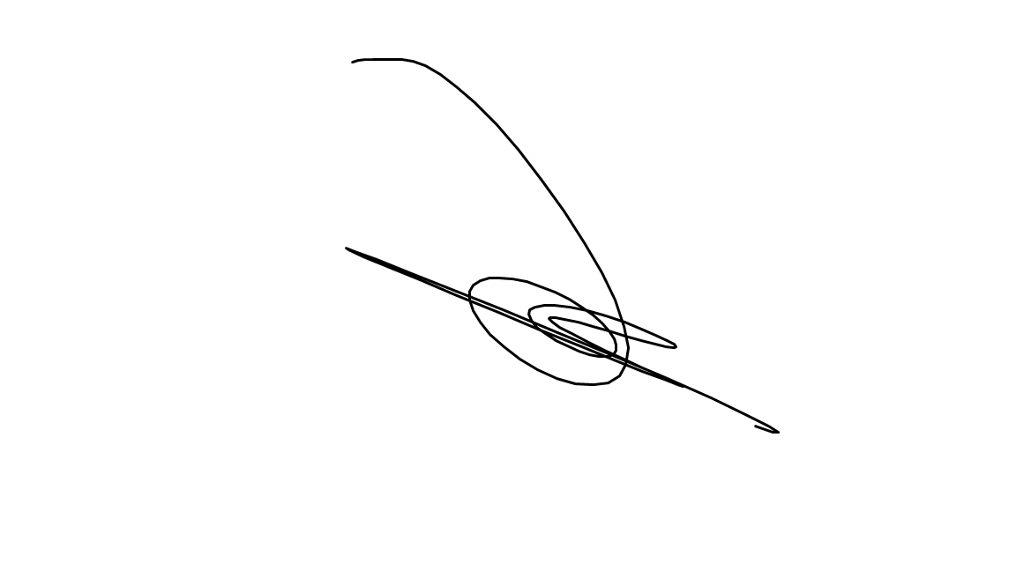

**검토/승인자 RM 김선정 (서명)**

**# 별첨(회의록 및 회의사진: 회의 등 모임을 가진 경우 각각의 모임별 회의록과 회의사진을 별첨 제출)**